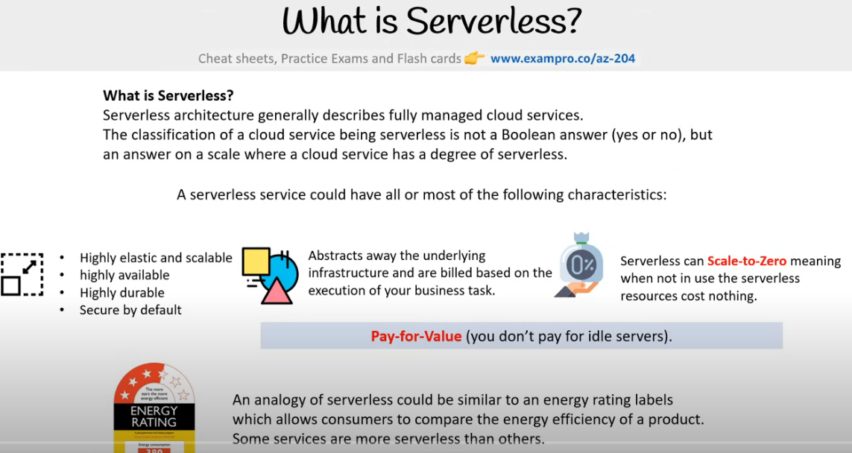

Serverless architecture is a software design model that lets developers build applications without managing the underlying infrastructure. The cloud provider handles the servers, so developers can focus on writing code. [1, 2, 3, 4]

How does it work? [2, 4, 5]
- Developers write code and package it into containers
- The cloud provider provisions servers to run the code
- The application scales up and down automatically as needed
- Developers only pay for the resources they use
Benefits of serverless architecture [4, 6]
- Cost-effective: Developers only pay for what they use, and there are no continuous costs for server operation [4, 6]
- Scalable: Applications can automatically scale up and down to meet demand [5]
- Faster development: Developers can focus on writing code instead of managing servers [3, 4, 7]
- Modular: Applications can be broken down into functions that can be developed, tested, and deployed independently [7]
Examples of serverless applications: Chatbots, Task schedulers, and IoT applications. [8]

Serverless architecture is also known as serverless computing or function as a service (FaaS). [9]

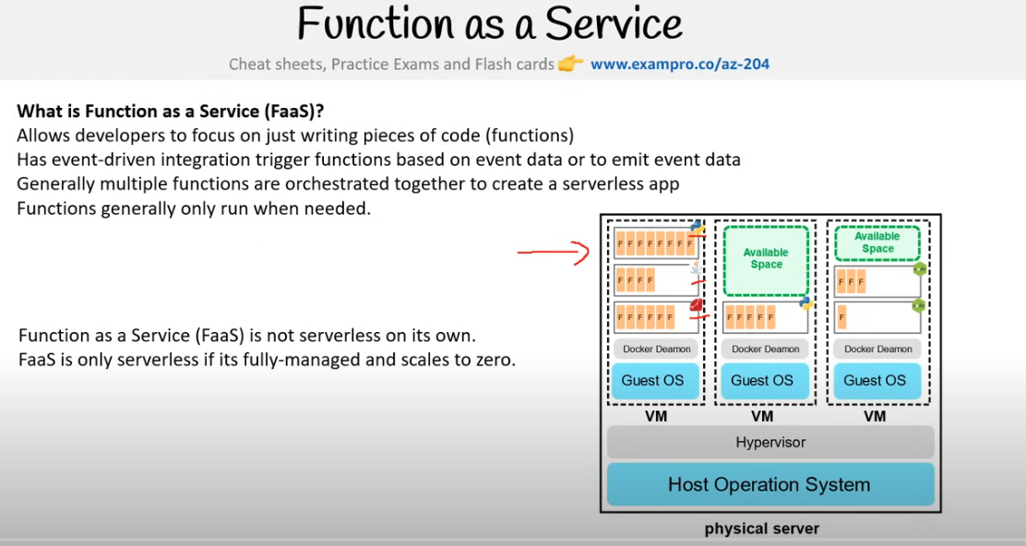

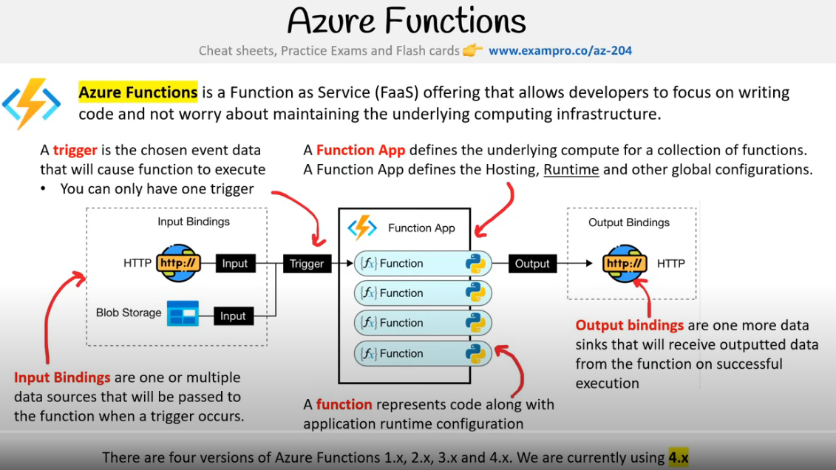

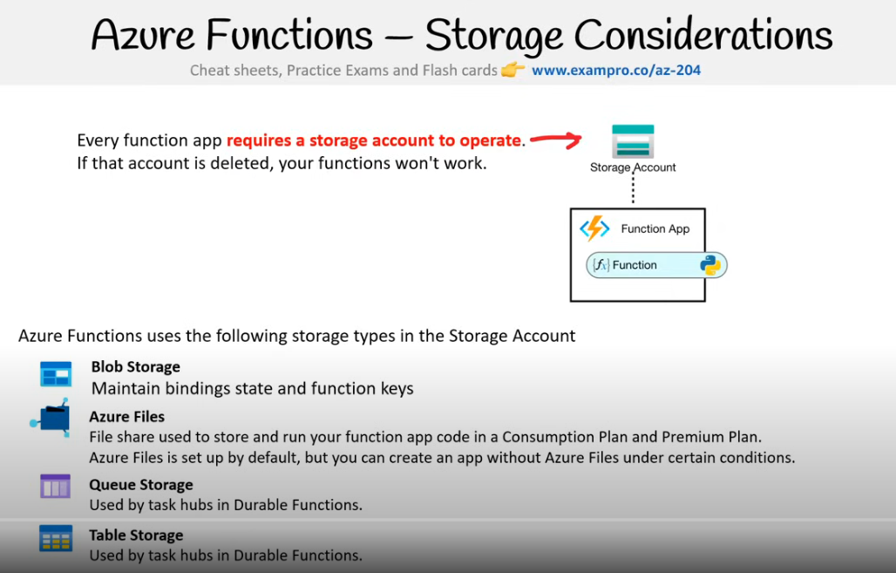

A Function App in Azure is not a part of a Storage Account; rather, a Function App requires a separate, dedicated Storage Account to operate, which is used for managing triggers, logging function executions, and other operations related to the Function App's functionality; essentially, the Storage Account is a necessary component for a Function App to function properly, but they are distinct entities within Azure.
Key points to remember:
- Separate services:
A Function App is a compute service for running serverless code, while a Storage Account is a data storage service.
- Dependency on storage:
When creating a Function App, you need to link it to a Storage Account to store data and manage execution details.
- Connection string:
The connection string to the Storage Account is configured within the Function App settings to enable interaction between the two services.



